**Report: The US Sovereign Debt Crisis during Pandemic**

**Name: Yunfei Fan**

**Introduction**

There are various uncertainties and risks in our unstable world. For my term project, I plan to analyze and model sovereign debt crisis. A debt crisis occurs when a country cannot repay its government debt. When government's tax revenue is chronically lower than its spending, a country is in a debt crisis. Usually, the government mainly raises money through taxes to finance its spending, but when tax revenue falls short, the government makes up the difference by issuing debt. This is largely achieved by selling government Treasury bills to investors on the domestic or external market. Recently, sovereign debt crises were in different forms [1]: one was direct default on domestic and external debt, the other one is liquidity crises in an illiquid rather than insolvent country, which means the investors’ unwillingness to roll over short-term debts.

When COVID-19 pandemic occurred, economic recovery is much slower than before, and sovereign debt has spiked. Looming debt crises caused accelerated inflation and price instability in many countries. Large differences in vaccination rates between countries also led to global economic divergence. Polarized connectivity like income disparities, political inequality furtherly led economic migration, social cohesion, especially those developing countries. [2]

This report aims at modeling sovereign debt crisis. The precipitating events of sovereign debt crisis will be analyzed first by using CART (classification and regression tree). The probabilities for precipitating events will be estimated by global economic data for the period from 1970 to 2002. This report will also predict the probability of sovereign debt crisis in the US during pandemic and the influence of each preventative actions on reducing sovereign debt risk by using Monte Carlo simulation.

**Descriptive Statistics on Data**

To build CART and estimate probabilities for the possible states of each precipitating event, the dataset includes economic data of 1276 episodes with market access in 79 countries for the period 1970 to 2012. [3] It summaries the countries, debt-crisis episodes, and related number of crises. The numbers of crisis and non-crisis episodes are displayed as following (*Table 1*).

|  |  |  |
| --- | --- | --- |
| Number of Crisis Episodes | Number of non-Crisis Episodes | Total |
| 261 | 1015 | 1276 |

*Table 1. Number of Crisis and Non-Crisis Episodes*

There are nine variables are selected: total external debt in percent of GDP; public external debt to revenue; short-term debt to reserves; exchange rate overvaluation; exchange rate volatility; external financing requirement to reserves; real growth; inflation; the U.S. treasury bill rate; and the number of years to next presidential election. I plotted probability density functions for some of these variables (*Figure 1-8*), and normal distributions are used to fit them.

*Figure 1-8. Probability Density Functions for some Variables*

The rule to identify a debt-crisis is based on Standard & Poor’s and International Monetary Fund (IMF) lending data. A country is defined as in debt crisis if Standard & Poor's considers it in default, or if it receives loans from the IMF that exceed 100% of its quota. Standard & Poor's rates sovereign issuer default if a country fails to pay principal or interest on its external debt at the due date. [4] External debt and public debt data is derived from Global Development Finance database (GDF) and IMF sources. Public finance data and other macroeconomic variables are from the IMF’s World Economic Outlook database as well as the Government Finance Statistics database (GFS).

To predict the probability of sovereign debt crisis in the US during pandemic, I collected data of total external debt, inflation, external financing requirement, and public external debt from US Department of Treasury.

**The Classification and Regression Tree Analysis**

***CART Tree***

I use a statistical technique called classification and regression tree (CART) analysis (*Figure 9)* to identify possible non-linear interactions between potential variables, which can help analyze precipitating events for a debt crisis and predict the probability of a crisis. The CART tree produces a set of rules to predict a binary result. It is nonparametric and can detect complex relationships between dependent and explanatory variables. It is particularly well suited to discovering nonlinear structures and variable interactions in data sets with many potential explanatory variables. [5] Rules are selected to reduce heterogeneity between the result group and the larger group where the rules are applied. Observations of specific groups have the same characteristics according to their classification rules.

The probabilities in the tree are estimated by the frequencies of crisis episodes in each state using economic data during the period of 1970 to 2022. The probabilities on the branches are conditional probabilities of debt crisis, while those on the terminals are probabilities of outcomes.

To evaluate the likelihood of sovereign debt crisis appearing in a government, I define it as crisis prone when the probability of a crisis is greater than or equal to 40%, which is represented by red nodes in CART tree. The resulting tree divides observations into crisis-prone and non-crisis-prone according to some features and their interactions.

The first split rule is external debt in percent of GDP: episodes with low external debt (less than 50 percent of GDP) go down, with conditional crisis probability of 24.13 percent; episodes with high external debt go up, then the second rule splits the episodes into high inflation (larger than 10.47 percent, with conditional crisis probability of 66.8 percent) and low inflation (with conditional crisis probability of 22.95 percent).

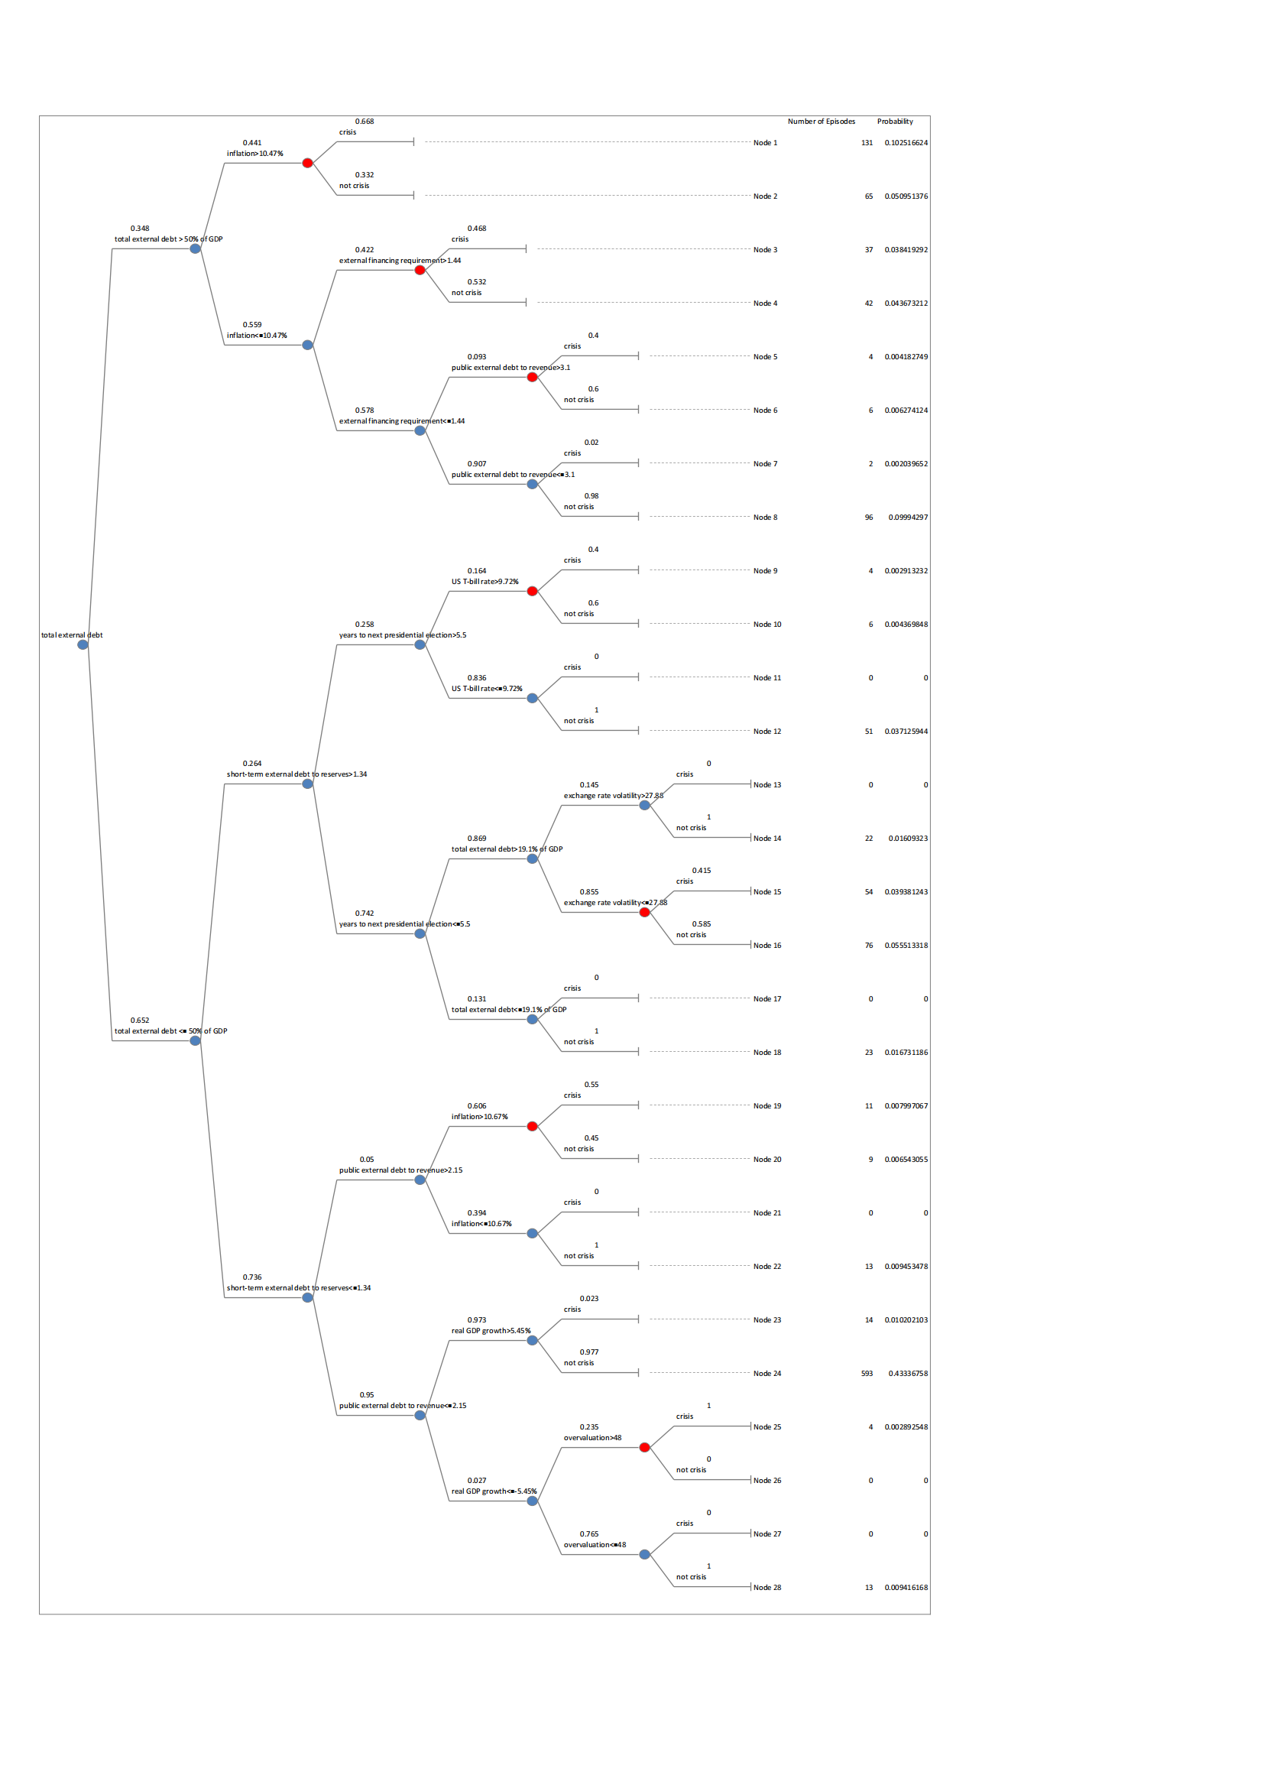

*Figure 9. The CART Tree*

***Result***

There are several interesting results shown in the CART tree. The state that is more favorable for reducing the risk of being in a crisis episode are low external debt, low short-term debt to reserves on a remaining maturity basis (below 1.34) and low public external debt to revenue (below 2.15), coupled with high economic growth. There is the largest number of episodes under this circumstance, but there is the lowest possibility to incur default risk, which is only 2.3 percent, see Node 23 and 24.

However, it is displayed that episodes of high external debt (more than 50 percent of GDP) and high inflation (larger than 10.47 percent) incur the largest default risk, 66.8 percent. More than half of all the crisis episodes in this state, see Node 1.

Additionally, according to the definition of sovereign debt crisis, it is often caused by unaffordable debt, but it is surprising that low external debt is not enough to remove debt crisis risk. When external debt is lower than 50 percent of GDP but higher than 19.1 percent with stable historical exchange rate (exchange rate volatility is lower than 27.88) and uncertain politics (year to next presidential election > 5.5), the default risk is high, see Node 15. When US T-bill rate is higher than 9.72 percent with low external debt and stable politics, the default risk is high, see Node 9. So does Node 19 and 25.

***Prediction of the Likelihood of Debt Crisis in the US during COVID-19***

Affected by COVID-19 pandemic, lots of countries are much more indebted than historic levels, even over the situation during World War 2. For advanced economics, the government debt during pandemic is 123.9 percent of GDP, which is almost equal to 124.1 percent of GDP during Post-World War 2. As for emerging markets, the current debt is 62.5 percent over the level during Post-World War 2 (46.9%). In the US, the total debt burdens (public and private debt) almost tripled from 2019Q4 to 2020Q3. [6]

The probability of sovereign debt crisis in the US during pandemic could be predicted by following our CART tree. The total external debt in percent of GDP is 133.6 percent [7] and the projected inflation is 7.9% [8]. With low external financing requirement to reserves (0.54) and high public external debt to revenue (6.5), the situation fits Node 5 and the US is crisis-prone with the 40 percent default risk. [9]

**Monte Carlo Simulation of Mitigating Actions**

Based on our result of CART tree, we cannot reduce the default risk just by pursuing low external debt. In order of probability of non-crisis, it has been noticed that the most favorable situation to avoid debt crisis is low external debt, low short-term and public external debt, coupled with high economic growth (Node 24). The second one is low inflation, low external financing requirement, low public external debt, even with high external debt (Node 8). The third one is low external debt, low short-term external debt, high political stability, and low US T-bill rate (Node 12).

To predict the influences of these three mitigating actions on reducing default risk, Monte Carlo Simulation is used. Using mean and standard deviation got by fitting dataset to normal distribution, I randomly create 500 episodes with economic data. The first ten rows are following (*Table 2*).

|  |  |  |  |  |  |  |  |  |
| --- | --- | --- | --- | --- | --- | --- | --- | --- |
| Episode | Total External Debt to GDP | Short-term External Debt to Reserves | Public External Debt to Revenue | Inflation | External Financing Requirement | Real GDP growth | Years to Next Presidential Election | US T-bill Rate |
| 1 | 74.61735962 | 3.014718 | 2.051413 | 19.04818 | 2.475096 | 6.318969 | 4.870754 | 6.924007 |
| 2 | 66.70481656 | 2.397444 | 3.147164 | 12.83519 | 3.906716 | 5.528604 | 5.146909 | 6.399128 |
| 3 | 67.69255822 | 3.514849 | 1.836989 | 8.329512 | 2.598679 | 4.965988 | 4.617891 | 7.520071 |
| 4 | 54.91793233 | 3.063669 | 2.406199 | 9.611741 | 1.110304 | 6.955461 | 4.961433 | 6.829483 |
| 5 | 16.18425388 | 4.258487 | 1.935774 | 11.9819 | 0.794115 | 4.028521 | 5.208297 | 6.339323 |
| 6 | 37.53298733 | 3.583727 | 1.674982 | 6.198315 | 2.490894 | 6.363294 | 4.477817 | 7.305992 |
| 7 | 59.156388 | 1.612154 | 2.861153 | 16.80965 | 1.746705 | 5.105504 | 5.132639 | 7.696065 |
| 8 | 28.00386407 | 2.057969 | 2.568254 | 13.49693 | 2.308034 | 5.905512 | 4.564679 | 7.052266 |
| 9 | 44.65896636 | 2.345275 | 1.433203 | 11.104 | 3.356423 | 8.294951 | 4.528154 | 7.681168 |
| 10 | 72.46702717 | 2.12768 | 1.919995 | 7.32205 | 3.036068 | 6.013491 | 5.831052 | 7.181621 |

*Table 2. Randomly Simulated Episodes*

Following the CART tree for each episode, the following result is gained (*Table 3*). In the most favorable situation, the first one, the probability of non-crisis is 0.433; in the second situation the probability of non-crisis is 0.100; in the third situation it is 0.037.

|  |  |  |
| --- | --- | --- |
|  | Number of Episodes | Likelihood of non-crisis |
| 1st situation | 34 | 0.433 |
| 2nd situation | 14 | 0.100 |
| 3rd situation | 19 | 0.037 |

*Table 3. Simulation Result*

The simulation result in the 3rd situation is unrealistic due to the assumption that the years to the next presidential election conform to normal distribution. This variable is integral in most countries and is often four or five. The number of episodes in the 3rd situation is expected to be less than that in the 2nd situation, but this assumption causes unrealistic result.

**Conclusion**

In conclusion, this report models and analyzes sovereign debt crisis. Nine precipitating events of sovereign debt crisis are fitted by normal distribution and analyzed by using CART. It is noticed that low external debt is not enough to remove debt crisis risk. Instead, the most safety state is low external debt, low short-term and low public external debt, coupled with high economic growth, and staying in this situation is the most effective action to mitigate sovereign debt risk. However, in Monte Carlo simulation, I find the assumption that the years to the next presidential election conform to normal distribution is not reasonable. Additionally, it is predicted the US is crisis-prone with the 40 percent default risk during the pandemic.

**Reference**

[1] Andrea Pescatori, Amadou N. R. Sy. "Are Debt Crises Adequately Defined?”. *Palgrave Macmillan Journals,* last modified August 21, 2007, accessed April 23, 2022, <https://www.jstor.org/stable/30036034?seq=1>

[2] Marsh McLennan. SK Group. Zurich Insurance Group. "The Global Risks Report 2022 17th Edition”. *World Economic Forum,* last modified January 11, 2022, accessed April 23, 2022, <https://www.weforum.org/reports/global-risks-report-2022>

[3] “Sovereign Defaults: Moving Higher Again in 2022?”. *Standard & Poor’s*, last modified January 24, 2022, accessed April 23, 2022.

[4] Paolo Manasse, Nouriel Roubini, Axel Schimmelpfennig. “Predicting Sovereign Debt Crises”*. International Monetary Fund,* last modified November, 2003, accessed April 23, 2022, <https://www.imf.org/external/pubs/ft/wp/2003/wp03221.pdf>

[5] Bhumika Dutta. “A Classification and Regression Tree (CART) Algorithm”, *AnalyticSteps*, last modified July 7, 2021, accessed April 23, 2022, <https://www.analyticssteps.com/blogs/classification-and-regression-tree-cart-algorithm>

[6] [Liz Capo McCormick](https://twitter.com/mccormickliz). “The Covid-19 Pandemic Has Added $19.5 Trillion to Global Debt”. *Bloomberg*, last modified January 28, 2021, accessed April 23, 2022, <https://www.bloomberg.com/graphics/2021-coronavirus-global-debt/>

[7] “United States External Debt”. *CEIC*, accessed April 23, 2022, <https://www.ceicdata.com/en/indicator/united-states/external-debt>

[8] “United States Inflation Rate”. *Trading Economics,* accessed April 23, 2022, <https://tradingeconomics.com/united-states/inflation-cpi>

[9] Tim Jones, Jubilee Debt Campaign. “Rising Debt Burdens, The Impact on Public Spending, and the Coronavirus Crisis”*,* last modified September 20, 2020, accessed April 23, 2022, <https://www.cgdev.org/sites/default/files/Jones-Debt-Paper-LICS.pdf>